先按装SET UP.在按装PL-2303VISTA

SIM Editor User Menu

Content

- I. Value Pack
- II. Hardware Request
- III. Installation
- IV. Program Functions
- V. Getting Started
- VI. How to edit the Phone Book
- VII. How to edit Short Message
- VIII. Key Management
- IX. System Configuration
- X. Languages Setting
- XI. Error Message

Index IThe editable reference table of Ring Tone and Picture Message for Nokia Model

- I. Value pack
When you open the box, please check those in that and make sure all things are exist. If something is not in the box, please contact the store where you bought this package.

  - 1. SIM Editor Software CD x1
  - 2. SIM Editor Card Reader with RS-232 interface x1
  - 3. SIM Editor user menu x1

[Top Of Page]

    - II. Hardware Request

Hardware:
      - 1. P II or above CPU, recommended is PIII 500.
      - 2. 64MB or more RAM.
      - 3. 20MB or more hard disk space.
      - 4. CD ROM.
      - 5. RS-232 serial port x 1.

Software:
Windows 98/ME/NT/2000/XP.

[Top Of Page]

- III. Installation

1. Auto Set Up : Please insert the CD into your PC and the Set Up Menu will show automatically. Users could select their own preferred language version to install the program.
2. Manual Set Up : If the Auto Set Up function has been disable, please double click the SETUP.EXE file in the CD for installation.

User can see SIM Editor program group after the program installed successfully. In the SIM Editor program group, User could find SIM Editor and Help icons.

- IV. Program Functions

SIM Editor is used for editing phone book, short messages, logos and ring tones. Now those functions in this programs are as below:

A. SIM Editor

User interface includes menu area, icon area and working area. In Menu area, there are complete functions list. Icons help user easy to use those functions.

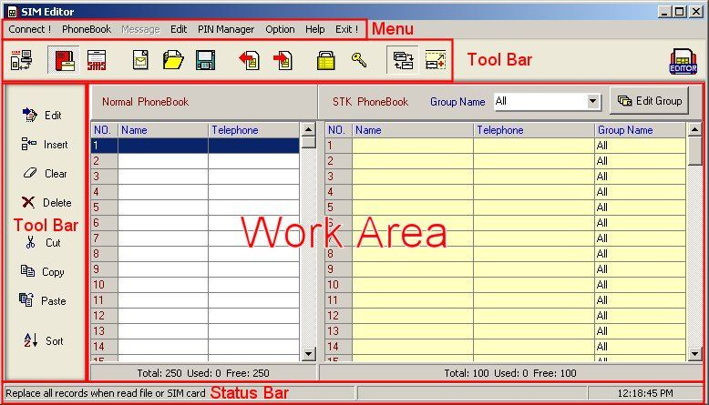

Functions:

No. | Function | Description
1. | Connect! | Program will connect to Card Reader, if program canˇt connect that, it will pop up a window with error messages.
2. | Phone book | Phone book functions group.
3. | New | Open a new phone book.
4. | Open | Open a phone book file.
5. | Save As | Save as a phone book file.
6. | Save to Text File | Save phone book data to a Text file.
7. | Read From SIM Card | Read phone book data from SIM Card.
8. | Write To SIM Card | Write Phone book data to phone book.
9. | Message | Short message function group/
 | New | Open a new message
 | Open | Open a exist message file
 | Save As | Save as a message file.
 | Save to Text file | Save to text file.
 | Read from SIM Card | Read short message
 | Write To SIM Card | Write Phone book to SIM Card.
10. | Edit | Edit function group
11. | Edit | Edit a record
12. | Insert | Insert a new record
13. | Clear | Clear a record.
14. | Delete | Delete a record
15. | Cut | Cut a record to clipboard.
16. | Copy | Copy a record to clipboard
17. | Paste | Paste a record from clipboard.
18. | Select all | Select all records.
19. | PIN Manager | PIN manager function group
20. | PIN 1 state | Set PIN 1 State
21. | PIN 1 Password | Set PIN 1 Password
22. | Option | Option
23 | System configuration | System configuration
24 | Language | Select language
25. | Help | Help function group
26. | SIM Editor Help | SIM Editor help file.
27. | About.... | About the program.
28. | Exit | Exit the program.

[Top Of Page]

- IV. Getting Started

1. Connect the PC and card reader.
2. Plug in the SIM card into userˇs reader with the IC chip face down.
3. Click the main menu 〃Connect〃 icon.
4. ¨Connection Successful〃 will appear if the connection is successful. If it fails, the dialog box ¨Connection Failure〃 will appear. Please double check the connection of the reader and card.

PSWhile inserting the new SIM card, users must click the ¨Connect〃 icon to let reader connect SIM card again, otherwise the error will occur.

[Top Of Page]

- V. Phone Book

Phone Book | Phone book editing
Open Option
Replace | Replace all the previous phone book
Append | Append phone book to the previous one.
Read from SIM card | Read the phone book data from the card
Write to SIM card | Write the phone book into the card
Open from file | Read the data from the Disk
Save to file | Write the data into the Disk

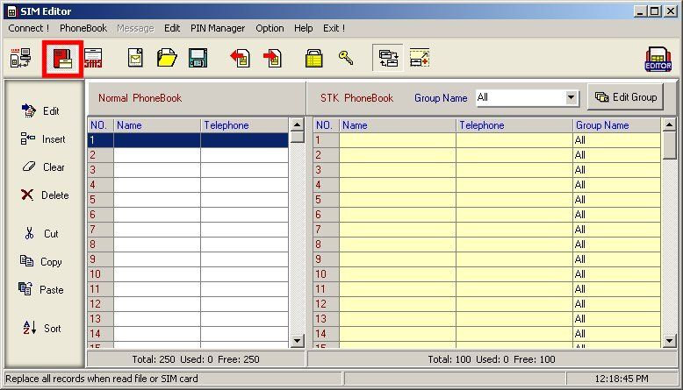Step 1: Click the edit button for editing the phone book.

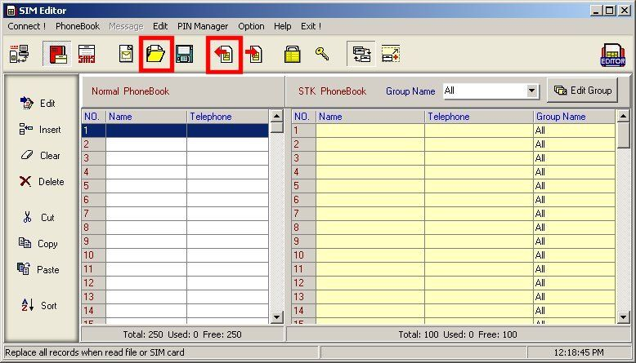Step 2: Click 〃Read from SIM card 〃 or 〃Read from file〃 button and read the data.

Step 3: There are modify, add and delete functions in the phone book editing application.
- 1. Edit  Click twice of your left button of the mouse or select the ¨Modify〃 button to enter the editor window.
- 2. Insert  Click the Add button to access to add window.
- 3. Clear  Clear a record for click the Clear button.
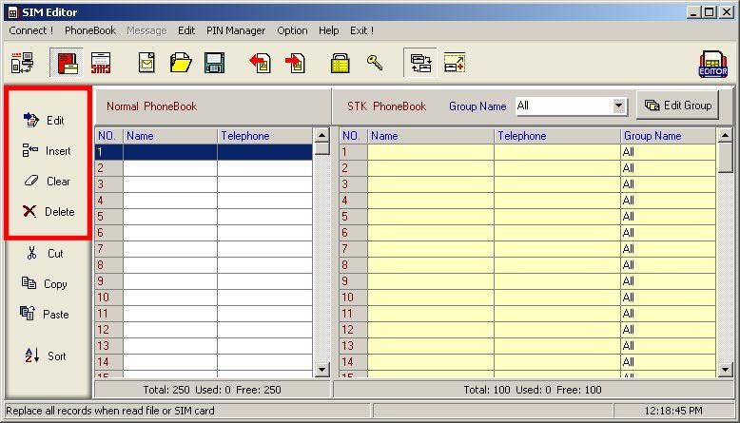Delete  Delete a record for click the delete button.
Step 4: Select add or modify window. Do not over flow the data while update the data. Can enter the international call ID symbol ¨+〃 and pause sign 〃P〃 (such as +886920111111 and 0225052525p123).

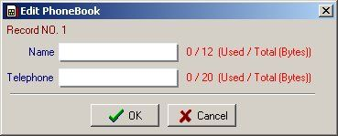

Step 5: Can write the data into the SIM card or save as PC file.

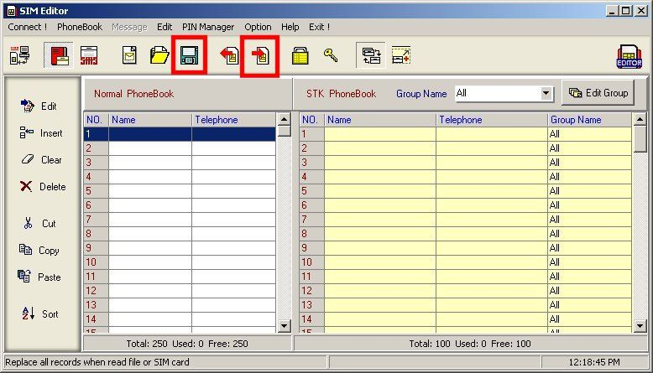

Additional phone book function:

Step1: Read the phone book data from the original SIM card and save to the PC.
Step2: Please select the ¨Open Option〃 Menu and decide the way to display the phone book data.
PS.
-  Replace --- Replace all the data with the original one.
-  Append --- Add a new data behind the original one.

Step3: After select the option mode, select the needed data and write into the card.
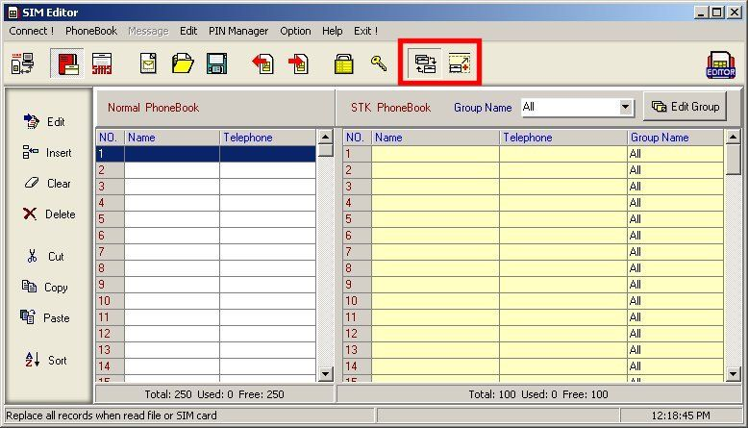

[Top Of Page]

- VI. Short Message

Short Message | Short message editing
Open Option
Replace | Replace all the previous phone book
Append | Append phone book to the previous one.
Read from SIM card | Read the SMS from the card
Write to SIM card | Write the SMS to SIM card
Open from file | Read the data from the Disk
Save to file | Write the SMS into Disk

Step 1: Select SMS edit pane
Step 2: Click 〃Read from SIM card 〃 or 〃 Read from file 〃button to read data.
Step 3: In the SMS edit panel, user can modify, add and delete.
- 1. Edit  Click twice of your left button of the mouse or select the ¨Modify〃 button to enter the editor window.
- 2. Insert  Click the Insert button to access to add window.
- 3. Clear  Click Clear button to clear a record.
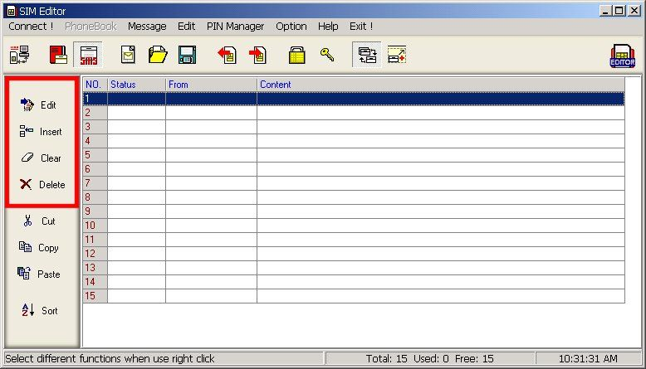Delete  Delete a record for click the delete button.
- 5. Sort Sort these records for click the sort button

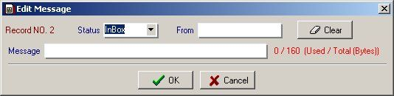Step 4: In the modify or add Window, please select 〃Short Message 〃item, then edit the new message and select the operator logo by select the 〃operator logo〃 item. For extra Ring tone, select 〃Ring〃 item.

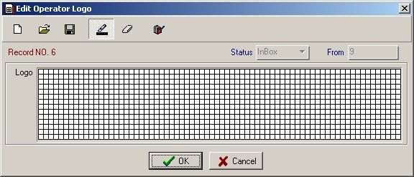Step 4.1: Add the Picture (Only for Nokia handsets)

- 1. New ---Can new the picture.
- 2. Open From File ---Can open logo picture file.
- 3. Save As File ---Can save logo picture file.
- 4. Pencil ---Can edit the picture.
- 5. Erase the pixel Erase the unwanted picture
- 6. Reverse logo image  Reverse the picture to opposite direction.

Step 4.2: Add Ring Tone (Only for Nokia handsets)
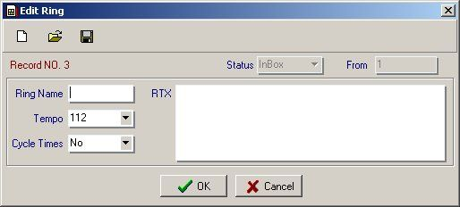

Description
- 1. Music compose panel Please compose RTX musical notation with a pace following with a tone. (Please take the menu of Nokia for reference.)

- 2. Name of MusicPlease key in the less than 8 digit English character as the name of the music. The name will display on the handset.

- 3. TempoPlease select the tempo of the music.

- 4. Frequency of the Ring tone  Can select from 0 to≯

Musical notation index:

Every sound is made of length of Musical Notation + note + Scale + Space. Please remember to enter the space insure a whole musical sound is formed.

The length of Musical Notation

Length of Note | Whole note | 1/2 note | 1/4 note | 1/8 note
Symbol char | 1 | 2 | 4 | 8
Length of Note | 1/16 note | 1/32 note | Dot
Symbol char | 16 | 32 | .

Musical Notation
Symbol Note | Do | Re | Mi | Fa | So | La | Si
Symbol char | C | d | e | f | g | a | B
Symbol Note | Do# | Re# |  | Fa# | So# | La# | Rest
Symbol char | #c | #d |  | #f | #g | #a

Musical scale
Musical scale | Sharp | Regular | Flat
Symbol Char | 3 | 2 | 1

PS. Users can download the RTX file from the Internet and paste the RTX file data into the RTX edit panel.

Step 5: Click the ¨OK〃 button after finish editing the file including the Ring Tone and Picture.

Step 6: write the data in card, on PC or print out.

Step 6.1: For double confirm data by accessing read commend to see if the data has been successful load into the card. (See below Diagram as an example. If the data is correct, operator logo column will feat back value 9 and the Tong column will be 1)
PS:
- 1. Outbox indicate SMS that will be sent.
- 2. Inbox indicate SMS that received in your handset.
- 3. 〃Ring〃---Where the ring tone should belong to..
- 4. 〃Operator logo〃---Where the picture should belong to.

Attention:

- 1. To access the new picture and ring ton, please insert your new editor SIM card into your handset. Select Message ---Inbox--- read the SMS that 〃9〃(indicate Picture) and 〃1〃 (indicate the ring tone) and forward again to user itself again.

- 2. Picture message is allowing only sending to user that has same operator system.

- 3. Ring Tone can send to others without any restriction.

[Top Of Page]

- VII. Key Management

- 1. Change status of PIN1/Unblock PIN1

- (1) User can change PIN in the condition of unblock PIN 1.

- (2) Please enter PUK1 to unblock the PIN 1.(If the PIN1 is under the condition of disable, please enable it first before entering the PUK1.

- 2. Change PIN number can modify new Pin of a card. Default setting of the card is PIN1 0000 with PIN1 disable. Users can manage the PIN by themselves through SIM Editor application.

[Top Of Page]

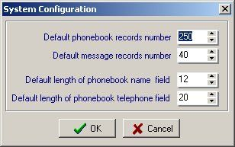System Configuration

  - 1. Default phone book records number: set up the default phonebook record number. Default value is 250.
  - 2. Default message records number: set up the default message records number. Default value is 40.
  - 3. Default length of phonebook name field: set up the default length of phonebook name field. Default value is 20.
  - 4. Default length of phonebook telephone field: set up the default length of phonebook telephone field. Default value is 12.
* Those setting would work depend on SIM cardˇs Speciation. If the value you setup is more then the maximums of SIM Spec and those records would not be wrote to SIM card.

[Top Of Page]

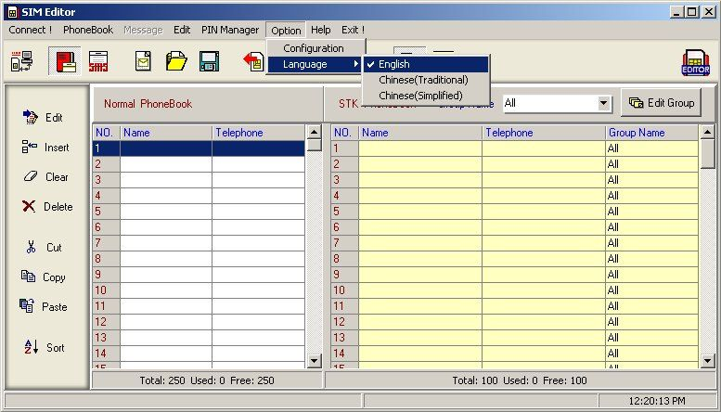Language Setting

Set up the language of user operation interface. There are three selections: English, Traditional Chinese and Simplified Chinese.

[Top Of Page]

- XI. Error Message

- 1. If it fails to read data, please remember to click the 〃Connect〃 button while push in or draw out a new card.

- 2. COM port has been used by another application. Please close the other applications while access the SIM Editor application.

- 3. Check whether SIM card has been proper placed. Please place chip with golden plate face down and the slash corner outside.
- 4. Defective SIM card or contact failure. Please clean the SIM card contact point.

[Top Of Page]

Index1The reference table of Ring Tone and Picture Message (only for Nokia)

Model | Ring Tone Editing | Picture Message Editing
3210 | V | V
3310 | V | V
3330 | V | V
5110 |  | V
5130 |  | V
5510 | V | V
6110 | V | V
6130 | V | V
6150 | V | V
6210 | V | V
6250 | V | V
7110 | V | V
8110i | V
8210 | V | V
8310 | V | V
8810 | V | V
8850 | V | V
8890 | V | V
9110 | V | V
9110i | V | V
9210 | V | V

[Top Of Page]

